Caleb Massey, Sam Bennett, John Dennison, Jackson Odell

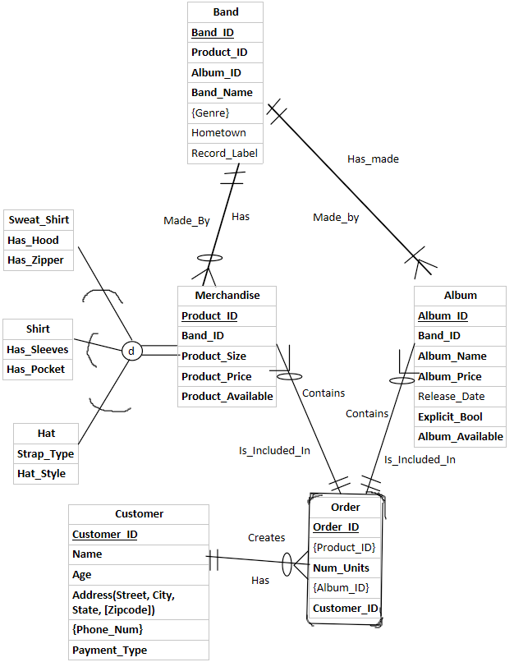

Entity Descriptions:

* Band: The Band entity contains information about each band such as its identification number, name, what genres it performs, the band’s hometown, and it’s record label. It also contains foreign keys for the merchandise and albums that it sells.
* Merchandise: A Super Type Entity that has attributes all common to the 3 types of merchandise sold. It includes information such as the product’s size, price, and availability.
  + Sweat_Shirt: A subtype entity that contains attributes such as whether a sweat shirt will have a zipper or not as well as if it will have a hood or not.
  + Shirt: A subtype entity that contains attributes such as whether a shirt will have sleeves or not as well as if it will have a pocket or not.
  + Hat: A subtype entity that contains attributes such as what type of strap it will have on the back as well as the style of the hat such as if it will have a flat or curved bill.
* Album: The Album entity contains information about each album such as a foreign key of the Band ID, the album’s name, price, release date, whether it is explicit or not and whether it is available or not.
* Customer: The Customer entity contains attributes that give information about the customer’s name, age, address, phone number, and payment type.
* Order: The Order Entity is an Associative Entity that represents the relationship between the Customer entity and both the Merchandise and Album Entities. This entity contains attributes such as the Order ID, foreign keys for the Merchandise, Album, and Customer entities, and the number of units being purchased.

Relationship Descriptions:

1. Relationship between Band and Album:
   1. Band has made one-to-many albums.
   2. Album is made by one and only one Band
2. Relationship between Band and Merchandise:
   1. Band has zero-to-many Merchandise items.
   2. Merchandise items are made by one and only one band.
3. Merchandise has a disjoint relationship with Sweat_shirt, Shirt, and Hat
   1. This a totally specialized relationship.
4. Relationship between Merchandise and Order:
   1. Merchandise is included in one and only one Order.
   2. Order contains zero-to-many Merchandise items.
5. Relationship between Album and Order:
   1. Album is included in one and only one Order.
   2. Order contains zero-to-many Albums.
6. Relationship between Order and Customer:
   1. Order has one and only one Customer
   2. Customer created zero-to-many Orders.